Description :
The SF100 is a high speed “In System Programming” programmer to update the SPI Flash soldered on board or Freescale MCU using Ezport. The programmer is easily controlled by the computer DediProg Software through the USB bus offering friendly interface and powerful features to users.
Features :  Update Serial Flash soldered on board with application powered or not  Update the internal Flash of Freescale MCU using the Ezport (MCF5223, MCF5221, MCF5213) or the external SPI Flash of Freescale MCU using the SBF interface (MCF5445, MCF5227)  Control Application, controller reset and MOSFET isolation status  Capable of handling two serial flash memories;(new feature; provided in SF100 with serial number DP001325, firmware 2.0.4, software 2.0.37 and after)  USB Interface  Start button feature  Signal conflict protections  Multi-Programmers Capability  Support Windows 2003 and above  Support both 32 bit or 64 bit OS |  |  |  |  |  |  |  |  | 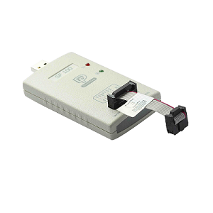
The SF100 USB software tool chain offers high flexibility and fit the different and highest requirements:
- Engineering Graphic User Interface:  for engineers and expert to access advanced features for development, repairing etc. |  |  |  | - Production Graphic User Interface:  for operators in production to control multiple programmers and improve the throughput. |  |  |  | - Command line interface:  Customer software can control the multi SF100 programmers (SF100 integration, Control SF100 with Production In Circuit Tester..)
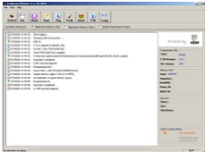 |  |  |  | 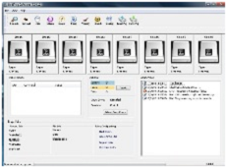
High performance(tested and measured with software version 2.0.37.2 and from a single source of serial flash memory supplier):
USB Mode
Density | 8Mb | 16Mb | 32Mb | 64Mb | 128Mb
Program | 7.28s | 13.09s | 28.01s | 52.4s | 74.01s
Verify | 2.57s | 4.64s | 8.08s | 17.09s | 33.78s
Auto(Program+Verify) | 8s | 14s | 37s | 70s | 108s
Hardware :
SF100 is designed with ISP header, through an appropriate connector; users can connect the programmer and drive the SPI signals, supply the memory and control the controller or application status. Please refer to Table 1 for the SF100 2x7 header pin out.
DediProg also provides the SF100 ISP Cable which is used to connect the SF100 programmer to the 2X4 2.54mm ISP Pin Header on board, please refer to Table 2 for the SF100 ISP Cable 2x4 pin out.
Table 1: SF100 ISP Header Pin Out (2x7)  1 I/O1 I/O4 2  3 I/O2 or CS2 NC 4  5 Vcc GND 6  7 CS CLK 8  9 MISO MOSI 10  11 Vpp/Acc I/O3 12  13 SCL SDA 14 |  |  |  |  | Table 2: ISP Cable Connector Pin Out (2x4)  1 Vcc GND 2  3 CS CLK 4  5 MISO MOSI 6  7 Vpp/Acc I/O3 8
Contents :  1x USB cable  1x SF100 Programmer  1x ISP cable | 1x SF100 Universal Adaptor  CDROM with Software, specifications and user manual
Hardware Requirement for ISP :
To have a clear understanding on the different ISP or backup boot methods and different reference schematics, please download our dedicated application notes: AN0103 and AN0106 in the documentation section
Option Purchase :  Backup Boot Flash-SO8N  Backup Boot Flash-Dual SO8N  Backup Boot Flash-SO8W  Backup Boot Flash-Dual SO8W |  |  | Backup Boot Flash-SO16W  Backup Boot Flash-Dual SO16W  BBF SO8 Testclip  BBF SO8 Testclip-Dual |  |  |  | BBF SO16W Testclip  ISP SO8 Testclip  ISP SO16W Testclip  SF100 Universal Adaptor

